Week 2 Workshop Tasks (Polymorphism)

- You want to call the info( ) method in more than one way. For example, if you have an extra message you want printed, you can use info(String), and info( ) if you have nothing more to say. Apply method overloading.

- Consider a cell phone where you can save your Contacts. Suppose a person has two contact numbers. For the ease of accessibility, your cell phone provides you the functionality where you can save two numbers under the same name.

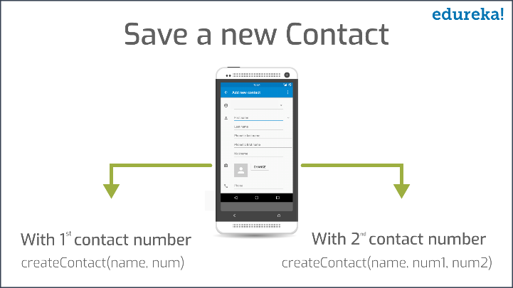

- Suppose you have a class named XJeans which includes a method named jeans(). Using this method, you can get an Allen Solly jeans. For the Jeans in the neighboring town, there is another class YJeans. Both the classes XJeans and YJeans extends the parent class ABCShoppingCenter. The YJeans class includes a method named jeans(), using which you can get both the jeans variants. Apply the concept of method overriding.

- Create a Bicycle class and extend it with a MountainBike and a RoadBike class. Bicycle class has gear(int type) and speed(int speed) as its fields and add printInfo method that prints gear and speed of the Bicycle instance. For MountainBike class, add a field for suspension, which is a String value and override the printInfo method that prints gear, speed and suspension of MountainBike instance. For RoadBike class add tireWidth field which is a integer value and override the printinfo method that prints gear, speed and tireWidth of RoadBike instance. Create a TestBikes class and create objects of Bicycle,MountainBike and RoadBike to test the overridden methods.

Use constructor to initialize the data fields of the classes and show the usage of super keyword.

- There is a hierarchy of greeting cards. The parent class is Card, and its children classes are Valentine, Holiday, and Birthday. A card object will have a greeting() method that writes out a greeting. Each type of card contains an appropriate greeting. The Holiday card says "Season's Greetings." The Birthday card says "Happy Birthday." The Valentine cards says "Love and Kisses." Apply the concept of method overriding. Make Card super class as abstract and it should have abstract method greeting(). Create a Test class to check all the overridden methods by creating objects of Valentine, Holiday, and Birthday classes.

